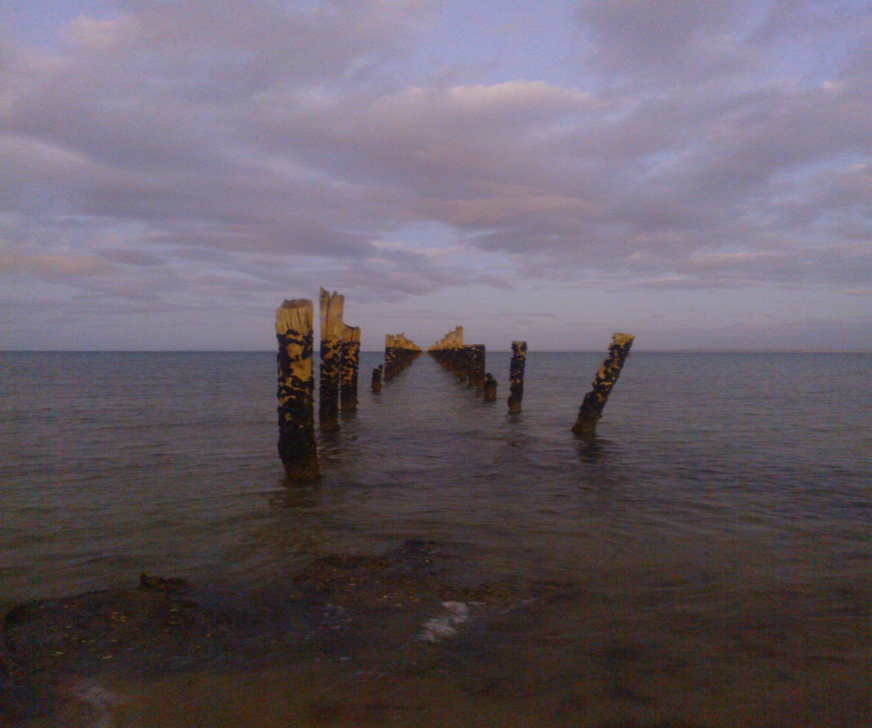
LOST AT SEA
SPRING No. 1
By Warwick McFadyen
And so we enter spring. Or spring enters us: the renewal of the earth, the unfolding of leaf and bloom in the enfolding warmth. The sun feels good on the skin, feels good on the face. The seasons may turn on an axis of indifference but in that turning is the difference. The sun feels good. Radiance abounds.
And so we enter spring. Or spring enters us: the rains come, and a lost lexicon of nature’s ways wells up. The drips, drops, splashes and sploshes, the squelches, the burbling, the cascading song of water, falling, hitting, running, finding its course into the earth, into other bodies of water or forming its own. Rain dance abounds.
Ah, the weather will have its way. Whatever we do is an adaptation, even when it is we who force the patterns of change.
We are forever acclimatising. As a species, it keeps us alive, which is laughable given our propensity to kill each other. We really are quite good at the latter - in all seasons, in all weather, at all times. And despite this we are also good at love. We are the perfect creature, the ideal paradox paradigm, a universe of worlds in motion against and with each other within the one frame of flesh, blood and bone.
We can string opposing words together and they can make sense to us: we love to hate, we hate to love, we dream to live, we live to dream, we forgive and forget, we forget and forgive.
But as a creature we are cruel. We may not seek delight in its implementation, but we do see advantage and in the delivering of that advantage resides the delight. And no turning of the seasons can sweep away that cold hard fact. History shows there are degrees of cruelty and different arenas in which cruelty is inflicted. It can be within a family, a relationship, a workplace, an institution or a random act. And it can be within a government that then reinvents cruelty as policy. The great horror of this manifestation is that the cruelty is inflicted upon one party to hurt another. The government calls it protecting our national borders. It is not ashamed of its actions. It defends them.
Prime Minister Malcolm Turnbull and Immigration Minister Peter Dutton will tell the world, via meetings at the United Nations in New York this week, that Australia’s way of dealing with refugees is a success story. This is a lie. It is only half the story. It suits the government’s purpose to extol the lack of boats reaching Australia’s shores as the beginning and end of the story.
It does not suit their purpose to tell the other half of the story: that asylum seekers are left to rot on Manus Island, Nauru and Christmas Island. They open their eyes each day to this prospect: indefinite detention. This is cruelty beyond measure. It is torture. It is a crime against the humanity most decent people would expect of one and another and especially of those they elect to represent them.
Welcome to Australia, refugees.
Recently former prime minister Tony Abbott was telling European conservatives that “effective border control is not for the squeamish, but it is absolutely necessary to save lives and to preserve nations’’.
Turnbull said, one supposes without a whit of embarrassment, that “public opinion will not accept a strong and generous humanitarian program, a generous migration program, unless the Government is seen to be in command of its borders”.
As to Dutton, his contortion of logic is such that Lewis Carroll if he were alive would have based a character on him to join Alice down the rabbit hole.
Recently, the minister said, one supposes again without a whit of embarrassment: “Australia has long been recognised as one of a handful of countries (with) the best resettlement arrangements in the world, and that word ‘resettlement’ is important. We don’t just provide a refuge, we guide people into a new life; a safe, healthy and hopefully happy life. We do all we can to help them overcome the traumas and tragedies they have experienced. Very few countries can say that.”
Earlier in the year, he became lazy and instead of supreme irony, just went for the cliché in portraying refugees who might dare live among us: “These people would be taking Australian jobs, there's no question about that.
“For many of them that would be unemployed, they would languish in unemployment queues and on Medicare and the rest of it, so there would be huge cost and there's no sense in sugar-coating that, that’s the scenario.”
Never mind that the cost of keeping a detainee offshore is, according to the Audit Office, almost $600,000 a year. And remember these despairing people are there indefinitely. This is how a civilised nation tortures. It takes away hope from a person. Is this how we treat people, whatever the circumstance in which they arrive to us, by applying the slow drip of cruelty? By going to such extraordinary lengths as to remove them not only from view but from the moral horizon?
Each nation likes to believe it has a moral core that allows it to transcend the grubby politics of the day; that the actions of government are derived from that core. The truth is that all that is good in the land of the fair go, in the sun-bronzed aspects of the national character that allows us to justifiably say we are a multicultural success story, is being eaten away.
Truth, like weather and nature, will have its way. And the truth is that a government that thinks it needs to inflict cruelty on others to maintain its strength is contemptuous of humanity. We cannot acclimatise to this.
There can be no spring in this political landscape while we leave refugees to rot.
Warwick McFadyen is an Australian freelance writer and editor

